Name___Jacob Blazina______________________________________
150 points possible (10 of which are for identifying where answers came from)

Rename the file to include your name (e.g. capaultmidterm). Open book, open notes (including our website and the links on it – no Google/Bing searches). NOTE: It is NOT permissible to use a midterm exam for notes from someone you know who took this course previously. Discuss your answers with no one until after the due date. You are on the honor system with regards to these items. You agreed to a code of ethics document as part of your acceptance into this department. Honor it!
IMPORTANT NOTE 1: For each problem, describe where your answer came from (self, book, notes, web address). Failure to do so will result in a loss of 10 points.

IMPORTANT NOTE2: NO LATE EXAMS WILL BE ACCEPTED FOR POINTS. CANVAS WILL DISABLE TURN-IN. YOU HAVE MANY DAYS TO COMPLETE THE EXAM – THERE ARE NO EXCUSES FOR A LATE EXAM.

For most questions you may use words, class diagrams or Java/C# code to illustrate your
answer, unless the question asks for a specific format. When you draw a class diagram, indicate the methods that make the pattern work. Also specify the type of relation (inheritance / composition) between classes and type of class (interface / abstract class / regular) as indicated in the sample UML class diagram on the right. You may also use the terms “is-a” or “has-a” to indicate the relationships. For each class & interface in your diagram indicate what it does. Use a circle to describe the responsibilities of each class, as necessary. The more detail you include; the better chance you have at earning full credit.

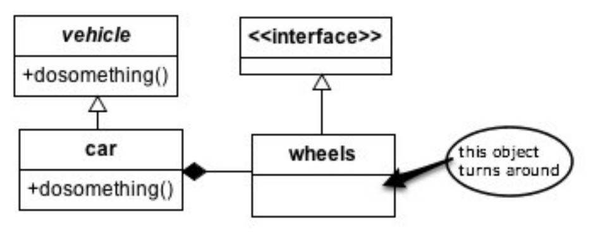
1. (8 points) Describe what the design principle “Tell, don’t ask” is about. Include in your discussion specifically how each of the Pillars of OO help achieve this principle.

(Lectures from 01.09.2019 and 01.10.2019, and my brain)

“Tell, don’t ask” is about declarative programming. Instead of a component needing logic to a) figure out how/what information to obtain and b) what to do with that information once it gets there, you would to “tell” that component a) the information and b) what you want it to do with that information. The component must then only rely on its own logic for doing a specific task with that information. This delegation solves many problems in OO programming.

Inheritance: Parent classes pass down information and functionality automatically to subclasses, this allows the subclasses to only have to worry about their more narrow and specific slice of the puzzle, and trusting that the parent class knows what it’s doing.

Abstraction: Generalization. Classes higher up in the hierarchy are most general and classes lower down are more specific. That way, the lower classes do not need to ask the higher classes about implementation details, the higher classes will provide all the information that they know about to the lower classes and the lower classes will act on that functionality or extend it themselves.

Encapsulation: Each component in a program only worries about itself. It has a specifc functionality, and if it needs something else done outside of its own scope, it sends the information down the chain and forgets about it, trusting that the next step will be carried out correctly just as it carried out its own job correctly.

Polymorphism: The idea of “many forms”, child classes have a more specific implementation of the parent class, and as long as methods are overridden properly, the child class will just perform it’s duties, not caring about how the parent class would have don’t it. If the child class doesn’t specifically address something, the parent class will “tell” it what to do.

2. (7 points) Why does inheritance violate encapsulation principles?

Inheritance violates encapsulation principles because it allows a child class to have access to all the information of a parent class. The principle of encapsulation is “none of your darn business” which means that how the methods of a particular class operate is not necessary for the outside world to understand.

(Lecture - Tuesday 01.08.2019)

3. (10 points) How are the Adapter and Façade patterns similar? How do they differ? Be very specific to ensure full credit.

Adapter and Façade are both structural patterns and work with preexisting classes. They both heavily rely on the principle of “program to an interface not an implementation”. Adapter is about converting an existing interface to work with another interface, while Façade is about creating a higher-level interface for a client to work with so that they client doesn’t need to understand how to work with multiple different interfaces itself.
Adapter has an interface that must be designed to, and requires an object to behave polymorphically, while Façade is for simplifying complex interface(s).

(Lecture Slide – Adapter Pattern)

4. (12 points) (a) Write a class diagram for the Template Method *and* then (b) the Factory Method design patterns. Note they are separate problems.
Follow the instructions for drawing and describing a class diagram on the first page of this midterm. NOTE: you should have two UML diagrams, one for each pattern. Each pattern must be applied to a specific scenario – don’t give the generic UML for the pattern. Be sure and include important features that guarantee the correctness of the pattern. The choice of the scenario is up to you. Examples from class are permissible! Once again, be sure and include the important features of each pattern that guarantee the pattern’s correctness.

- Template Method (Lecture slides and HFDP book)
TomatoSoup is-a Soup.

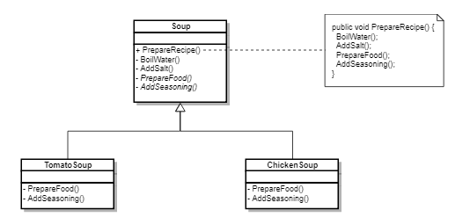

- Factory method (Lecture slides and HFDP book)
DesertPieFactory is-a PieFactory
PieFactory has-a Pie
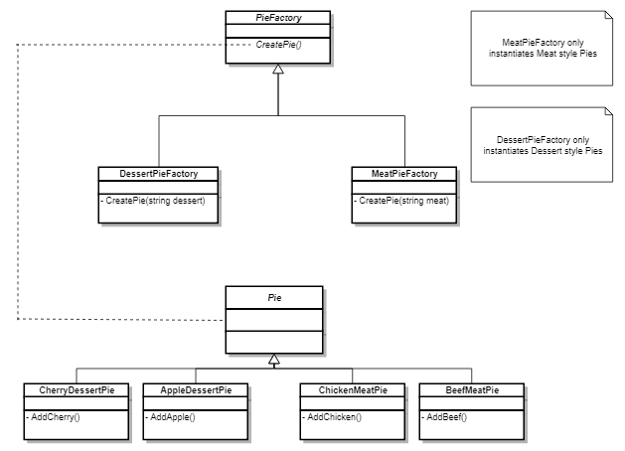
5. (10 points) (a) Thoroughly describe the following OO principles then (b) list at least one pattern that follows each principle: Single Responsibility, Open/Closed, Liskov Substitution, Interface Segregation, Dependency Inversion (SOLID).

(Lecture Slides and Lecture Notes)

Single Responsibility: Any method or class should be encapsulated to the point that it only affects a specific piece of functionality. Any changes to other parts of the program should not affect that method or class, and visa versa any changes to that class or method should not affect other parts of the program.

Example: Chain Of Responsibility Pattern

Open/Closed: Any method or class should be open for extending or adding to the functionality but closed to manipulating directly how that class/method functions.

Example: Decorator Pattern

Liskov Substitution: Being able to swap out a parent class for one of its subclasses. For instance, we could reference a “Student” class object or exchange it for a “GradStudent” class object and be able to expect the same functionality form the “GradStudent” class object that we would expect from the “Student” class object.

Example: Strategy Pattern

Interface Segregation: There should be interfaces specific to each class, that can be acted on individually instead of having one giant interface that deals with multiple implementation details.

Example: Observer Pattern

Dependency Inversion: The principle of having an abstract class or interface in between every concrete class and subclass. If the parent class and the subclass are both programmed to an interface, then we aren’t programming either to an implementation.

Example: Strategy Pattern

- (15 points) List 5 code smells, describe what each means, and describe how to re-factor each.

(Coding horror code smells, lectures slides, smells to refactoring guide, and experience)

  - Duplicated Code – A good way to avoid duplicated code is by programming to interfaces and not implementations. If you have a good abstraction layer, then you only have to write code to deal with the things that are different and not write code for what stays the same.
  - Long Methods – If you have methods that are way to long, it is a good indicator that you are not encapsulating properly. A way to refactor is by breaking the method into shorter, more specific methods that follow the Single Responsibility Principle.
  - Too many Comments – If you have comments explaining the “what” of what your code is doing, instead of the “why”, that is a code smell. Refactor by using better naming of methods headers and variables, so that a human can follow along with exactly what a section of code is trying to do. Leave comments for “why” situations.
  - Refused Bequest – A subclass that never needs or uses the functionality that is inherited from a parent class. A way to refactor is to separating the hierarchies, so that you don’t have needless inheritance. Another good way to refactor that is to focus on delegation, instead of inheritance.
  - Shotgun Surgery – A change to one class requiring subsequent changes to other classes. This is a blatant violation of Single-Responsibility and can be remedied by more narrow classes and using interfaces to abstract the functionality between two classes.

- (6 points) Describe coupling. Describe cohesion. Which combination of coupling and cohesion is most desirable?

(OOA_D lecture slide)

Coupling: Having two methods, classes, or general functionalities connected so that any changes or details in one has affects on the other.

Cohesion: Having the details of a method, class, or general functionality be closely related, to follow the Single-Responsibility principle that all parts of a particular thing are working towards the same goal.

The most desirable combination of coupling and cohesion is to have strong cohesion and loose coupling. That allows for very useful and specific members of a program and so they may act separately without interference from the other members of the program.

Design Problems
Four design problems are listed on the pages that follow – you must provide solutions for three. If you solve a fourth, that one is worth 10 points extra credit (clearly label which is extra credit if you attempt it, please). Select the most appropriate design pattern to use to address the problem and clearly motivate how it addresses the problem. Furthermore, show an appropriate class diagram followed by enough code fragments to illustrate the implementation of your pattern.

To clarify, you will do three things for each problem. First, list a pattern that you think best solves the problem along with justification for why you chose it/ why it works. Second, draw UML that represents that pattern in the context of the problem. Third, include code fragments/snippets that illustrate application of the pattern.

8. (20 points) You work for a company that develops medical imaging equipment. You developed a medical imaging application which collects data from a computed axial tomography (CT) scanner via TCP/IP sockets. The imaging application was originally
written to communicate with one scanner but was expanded when your company started to develop a functional magnetic resonance imaging (FMRI) scanner. Unfortunately, this FMRI scanner does not speak the same language as the CT scanner. Marketing required your application to support both types of scanners, since the imaging software is the same for both types of scanners and hospitals may use the scanners in tandem. The R&D department of your company recently announced that they will launch a photo acoustic (PA) scanner in the near future which use a different communication protocol than the CT and FMRI scanner. Because this is medical software it runs on custom operating system that is ultra-reliable and consequently does not support unreliable hardware abstraction through drivers. This means the drivers for the scanners are part of your application. Your application works as follows: you place a patient in the scanner and press the scan button upon which the scanner will send a request for image transmittal to your application. Your software keeps track of which driver is required for which IP address.

- EXTRA CREDIT: I chose the Observer pattern in conjunction with the Adapter pattern. The reason being that since the hardware itself has immutable functionality and must work asynchronously, our software client must always be waiting for a request to come in via the “Scan” button. Once that request hits, we must then differentiate the subject based on the IP address and then act on the request in a specific way based on that subject. Our “driver” abstraction would be the observer, with each imaging scanner being the subject.

- UML: CTScanner is-a Scanner, Scanner uses-a Application.
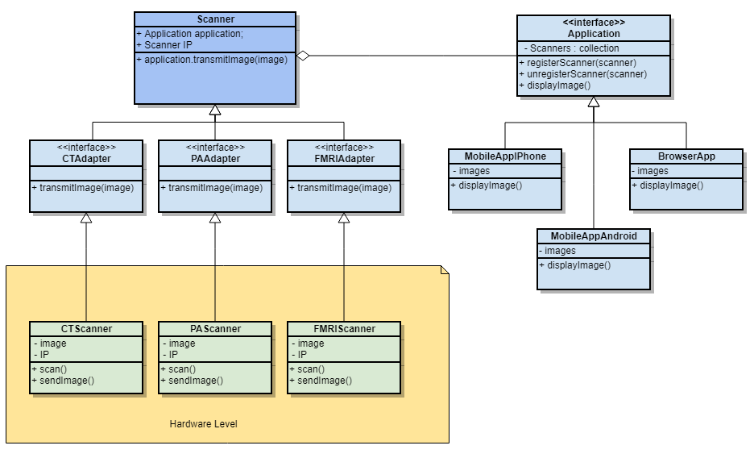

- Code snippets:

9. (20 points) You work for a webhosting company that offers a ton of hosting services (Flash Media, MySQL, Subversion) to its customers in addition to a base web hosting
plan. You need to write an application that can easily compute the total monthly service
fees for each plan. Your application must be able to easily support adding new types of
hosting services (such as Ruby on Rails) when they become available.

Sample output could be:
> Basic Hosting, Subversion Hosting, Flash Media Server Hosting, MySQL Hosting(w/3 databases): 59.94 a month.

- Decorator Pattern. Because we are adding multiple services on top of a basic web hosting plan, it makes sense to decorate that plan with as many services as we would want, tracking the description of the service and the total cost. We can easily create concrete classes for upcoming hosting services and they can be added on later.

- UML: BasicHostingPlan is-a HostingPlan && HostingPlan has-a WebHostingService
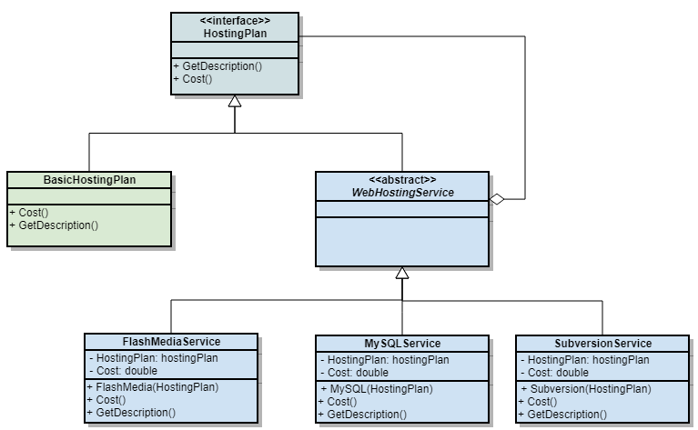

- Code Snippets:
public abstract class WebHostingService
{
protected string HostingServices = "Unknown Web Hosting Service";
public abstract string GetDescription();

public abstract int Cost();
}

public class BasicHostingPlan : WebHostingService
{
public int cost = 50;
public BasicHostingPlan()
{
}
public override string GetDescription()
{
return "Basic Hosting";
}
public override int Cost()
{
return this.cost;
}
}

public class FlashMediaService : WebHostingService
{
private HostingPlan hostingPlan;
private int cost = 10;

public FlashMediaService(HostingPlan hostingPlan)
{
this.hostingPlan = hostingPlan;
}

public override int Cost()
{
return cost + hostingPlan.Cost();
}

public override string GetDescription()
{
return hostingPlan.GetDescription() + ", Flash Media Service";
}
}

Public void Test_Services(){
WebHostingService hostingService = new BasicHostingPlan();
hostingService = new FlashMediaService(hostingService);

//outputs: Basic Hosting Plan, Flash Media Service, $60 a month
}

10. (20 points) You are writing a nifty photo application that can read different photos and then creates thumbnails out of them. Your program supports different image formats (JPG, GIF, PNG etc), which are represented by different reader classes for each format that converts the image to an intermediate decoded image format. You anticipate supporting different types of new images in the near future.

- Factory Method Pattern – a photo factory will be able to create thumbnails from an image regardless of what the original type is. Any new file types that come in will just need to have a corresponding implementation of that interface.

- UML: JPGFactory is-a ThumbnailFactory

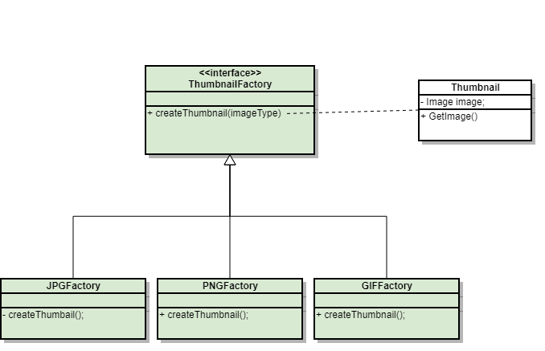

- Code snippets:

Public interface ThumbnailFactory{
Public Thumbnail CreateThumbnail(type, image){
Switch (type){
case “JPG”:
return JPGFactory.createThumbnail(image);
case “PNG”:
return PNGFactory.createThumbnail(image);
case “GIF”
return GIFFactory.createThumbnail(image);
default:
throw TypeNotSupportedException(type);
}
}

public static class JPGFactory{
public Thumbnail createThumbnail(Image image){
return ImaginaryDecoderLibrary.DecodeJPGToThumbnail(image);
}
}

11. (20 points). You have been hired to work for a web-based personal financial management service (like mint.com). Users can get an overview of their financial situation and they can add checking, savings and credit card accounts from different banks that are conveniently compiled into one or more views. Users can access this financial management service either through a desktop application or a mobile device like an iPhone which have different screen sizes and interaction capabilities and hence different views may be required. Bank accounts are checked periodically and whenever a new transaction is detected views must be updated.

- Observer pattern, the subjects will be the different accounts, like checking, savings, and credit card accounts. The abstract observer will be watching these accounts for changes, and when it sees a change it will pass the notification down the chain to the views.
- UML: CheckingAccount is-a Observable, BrowserView is-a View, Observable has-a View(observer)
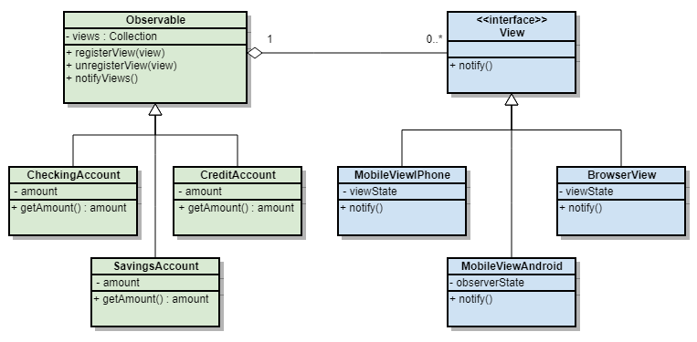

c)
public class Observable {
private List Views;

public void RegisterView(View view){
Views.Add(view);
}

Public void UnRegisterView(view){
Views.Remove(indexOf(view));
}

Public void notifyViews() {
Foreach(view in Views){
View.notify();
}
}
}

public class CheckingAccount : Observable {
private double amount;
public CheckingAccount();

Public void amountChanged(){
Notify();
}
}

Public void Test_Views(){

Observable obs = new Observable();
CheckingAccount.Amount = 200;
View iphone = new MobileViewIPhone();
Obs.Register(iphone);
//iphone.viewState = {Amount: 200}

CheckingAccount.Amount =- 100;
Iphone.viewState = {Amount: 100};
}

12. (6 points) What is a design pattern? What benefits does a pattern provide a community of developers?

(HFDP book and Lecture Slides)

A design pattern is a way of solving a problem that has or may repeat itself, that is reusable in such a way that one could apply it to many different scenarios. A design pattern is a sort of language, that designers can use to effectively communicate about abstract scenarios and specific implementations. A design pattern consists of a Name, a Problem that is solves, the Solution to solving the problem, and the Consequences involved with implementing that pattern.

Design patterns provide many benefits to the developer community as a whole, the main one being the source of a common language, so that things may be communicated effectively, and when someone solves a problem, that solution can be passed to other developers without them having to go through the same trial and error steps as the original.

13. (6 points) Describe the difference between published and public with regards to interfaces as discussed by Eric Gamma on the link provided on our website. The discussion references Martin Fowler, who formally identified the difference between the two. NOTE: In describing the difference between two items, you must clearly define what each means, then you can clearly and correctly point out the difference(s).

(Provided Link and experience)

Published: The part of the API (interface) that is meant to be accessed by the outside world. Once an interface is published, it’s assumed that it can and will be used by other people, who have no access to the internal workings of the program.

Public: The API (interface) that is meant to be accessed “internally” by other classes and methods in the program. Being public, any other pieces of the program can use it, but that is not the same as being published to the outside world.

The differences between published and public is that something that is published is the part of your programming that the outer world is building against, if you change something that is published, you will not be able to ascertain what things will break for those who have been using that published interface. When it is public, changing the interface may still break things, but they are things that live inside your own code base and is much easier to predict and fix those changes on your own, with other programmers in the outside world being none the wiser.

